Architecture:
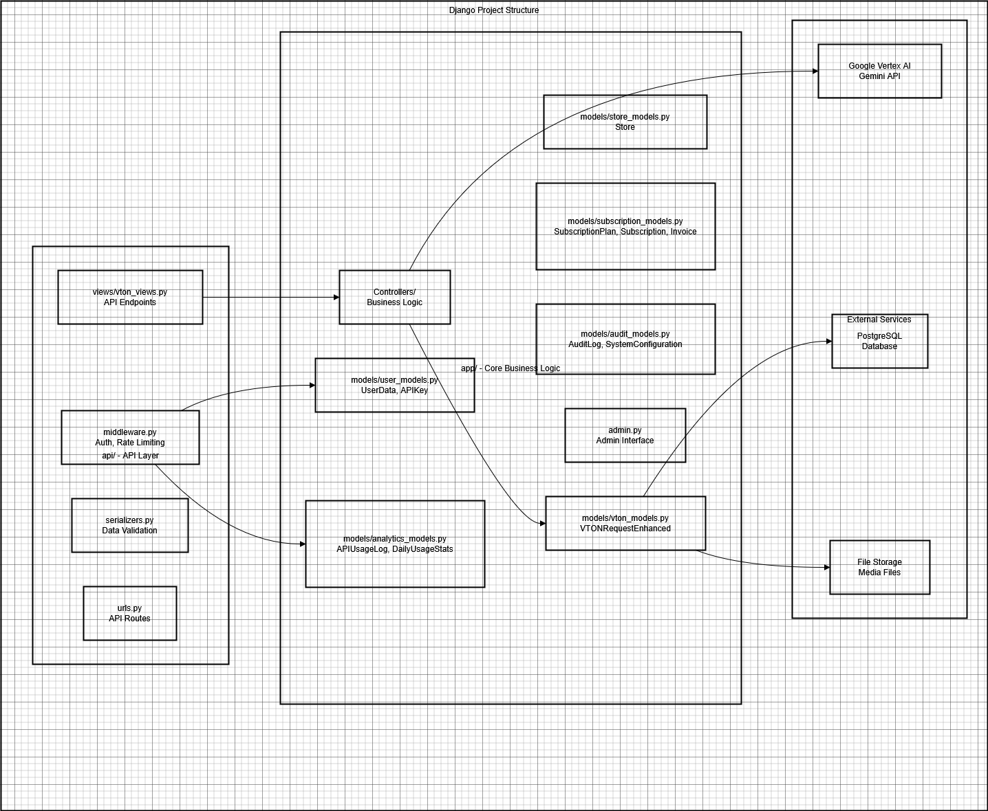

Data Layer
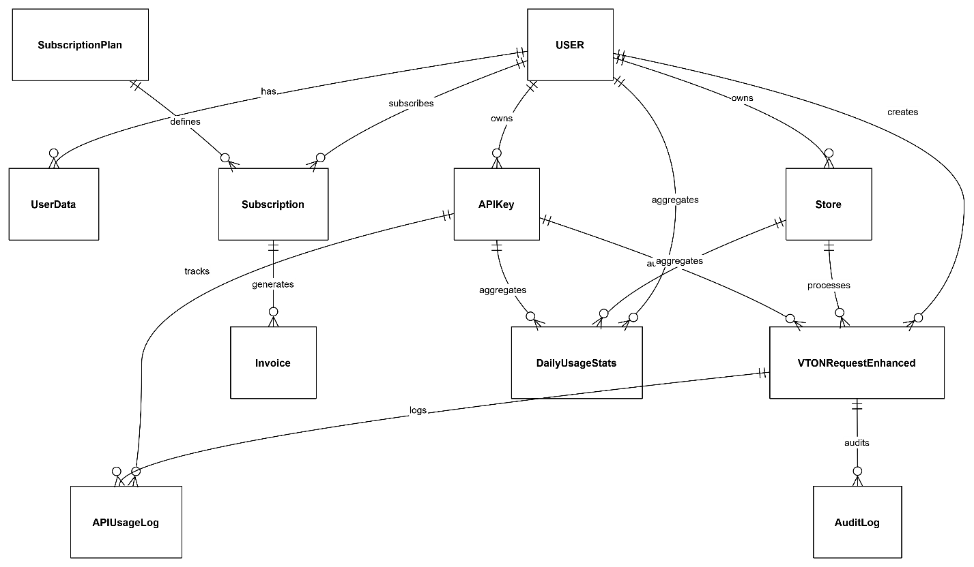

Project structure:
VTON_APP/
├── app/ # ✅ CORE: Business Logic & Data
│ ├── models/
│ │ ├── __init__.py # Import all models
│ │ ├── user_models.py # UserData, APIKey
│ │ ├── store_models.py # Store
│ │ ├── vton_models.py # VTONRequestEnhanced
│ │ ├── subscription_models.py # Plans, Subscriptions, Invoices
│ │ ├── analytics_models.py # APIUsageLog, DailyUsageStats
│ │ └── audit_models.py # AuditLog, SystemConfiguration
│ ├── Controllers/
│ │ ├── VTONController.py # VTON business logic
│ │ ├── HelpersController.py # File handling, utilities
│ │ └── SubscriptionController.py # Billing logic
│ ├── admin.py # Django admin configuration
│ └── migrations/ # Database migrations
│
├── api/ # ✅ API LAYER: External Interface
│ ├── views/
│ │ ├── vton_views.py # VTON API endpoints
│ │ ├── auth_views.py # Authentication endpoints
│ │ └── store_views.py # Store management endpoints
│ ├── serializers.py # DRF serializers
│ ├── middleware.py # Rate limiting, logging
│ ├── urls.py # API routing
│ └── utils/
│ └── validators.py # Input validation
│
├── VTON_APP/ # ✅ PROJECT CONFIG
│ ├── settings.py
│ ├── urls.py
│ └── wsgi.py
│
└── manage.py

Scaling:
